EASTERN INTERNATIONAL UNIVERSITY Practice Assignment – Quarter 3 , 2024-2025
SCHOOL OF COMPUTING Course Name: Database
AND INFORMATION TECHNOLOGY Course Code: CSE 301
Student’s Full Name: Nguyễn Khắc Duy
Practice Assignment 7
Student ID: 2131220021
Instruction:
* Students use latex to write relational algebra language for the following queries. After finishing the assignment, students must export into a PDF file. Finally, students upload the file in Moodle.
- Give a database ‘SaleManagement’:
Clients(Client_Number, Client_Name, Address, City, Pincode, Province, Amount_Paid, Amount_Due)
Product(Product_Number, Product_Name, Quantity_On_Hand, Quantity_Sell, Sell_Price, Cost_Price)
Salesman (Salesman_Number, Salesman _Name, Address, City, Pincode, Province, Salary, Sales_Target, Target_Achieve, Phone)
Salesorder(Order_Number, Order_Date, Client_Number, Salesman_Number, Delivery_Status, Delivery_Date, Order_Status)
Salesorderdetails(Order_Number, Product_Number, Order_Quantity)

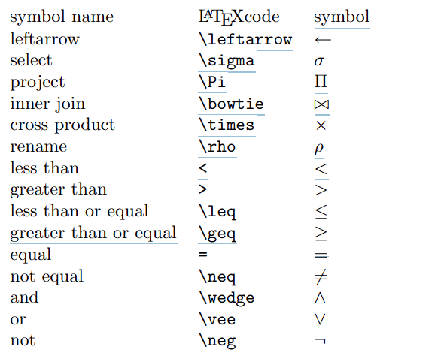
Practice in Class
- Using Logical Operators
- Show the all-clients details who lives in “Binh Duong”.
- Find the client’s number and client’s name who do not live in “Hanoi”.
- Identify the names of all products with less than 25 in stock.
- Find the salesman’s details who are able achieved their target.
- Select the names and city of salesman who are not received salary between 10000 and 17000.
- Show order date and the clients_number of who bought the product between '2022-01-01' and '2022-02-15'.
- Finding strings in table
- Select all clients details who belongs from Ho Chi Minh, Hanoi and Da Lat.
- Choose all clients data who do not reside in Ho Chi Minh, Hanoi and Da Lat.
- Find the clients details who has due more than 3000.
- Find the clients name and their province who has no due.
- Show details of all clients paying between 10,000 and 13,000.
- Display all product name and their corresponding selling price.
- How many TVs are in stock?
- Display all salesman details who are received salary between 10000 and 20000 and achieved their target.
- Using functions (Min(), Max(), COUNT(), AVG() and SUM())
- Find the average salesman’s salary.
- Find the name of the highest paid salesman.
- Find the name of the salesman who is paid the lowest salary.
- Determine the total number of salespeople employed by the company.
- Compute the total salary paid to the company's salesman.
- Using Order by keyword, limit clause
- Select the salesman’s details sorted by their salary.
- Display salesman names and phone numbers based on their target achieved (in ascending order) and their city (in descending order).
- Display 3 first names of the salesman table and the salesman’s names in descending order.
- Find salary and the salesman’s names who is getting the highest salary.
- Find salary and the salesman’s names who is getting second lowest salary.
- Display the first five sales orders in formation from the sales order table.
- Display next ten sales order information from sales order table except first five sales order.
- Using group by with having clause with aggregate functions (COUNT(), MAX(), MIN(), SUM(), AVG()), order by.
- If there are more than one client, find the name of the province and the number of clients in each province, ordered high to low.
- Display information clients have number of sales order more than 1.
Practice to grade
Question : Using database ‘SaleManagerment’ to write SQL queries following:
- Find the salesman’s details who are not able achieved their target.
- Display all salesman details who are received salary between 20000 and 30000 and not achieved their target.
- Find client names whose second letter is 'r' or second last letter 'a'.
- Select all clients where the city name starts with "D" and at least 3 characters in length.
- Select the salesman name, salaries and target achieved sorted by their target_achieved in descending order.
- Display the product name, cost price, and sell price sorted by quantity in hand.
- Display client information based on their city, sorted high to low based on amount due.
- Display last five sales order in formation from sales order table.
- Count the pincode in client table.
- How many clients are living in Binh Duong?
- If there are more than three clients, find the name of the province and the number of clients in each province.
- Display product number and product name and count number orders of each product more than 1 (in ascending order).
- Find products which have more quantity on hand than 20 and less than the sum of average.

